Manipulated Image
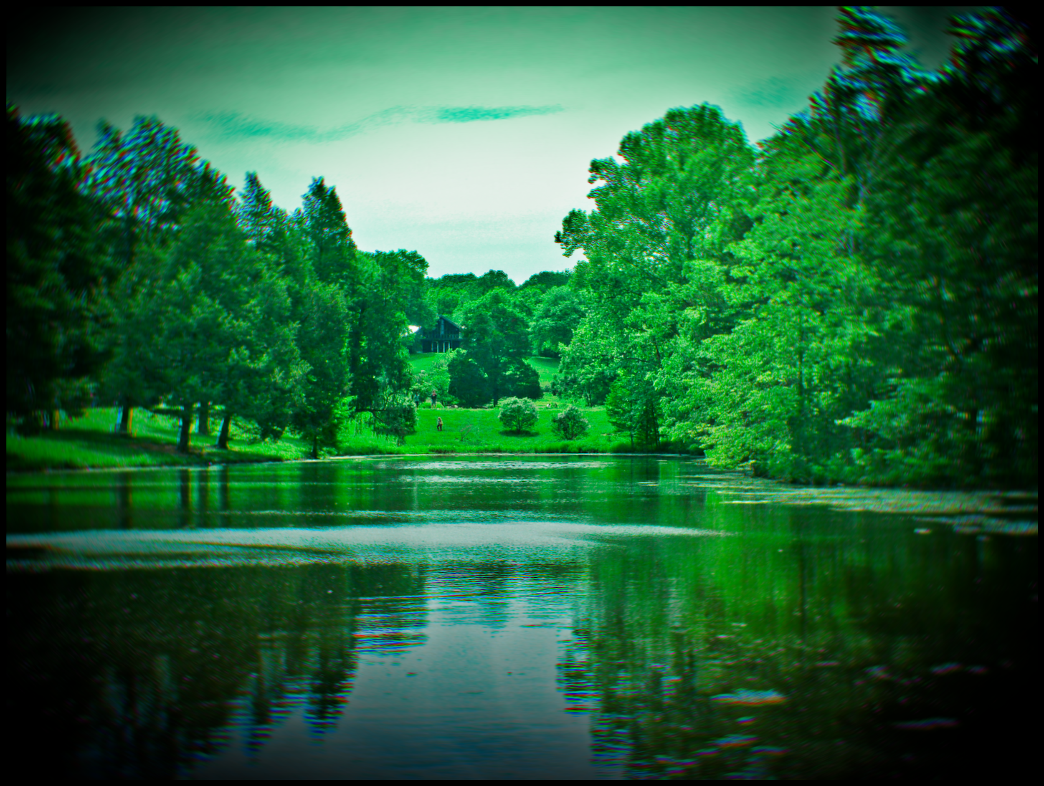
At first, I used the dehaze tool to clean up the photo and enhanced the shadows, added more black, and also got rid of all the highlights in the image to give it a darker feel. I added fringing on the image with some rotation blur, which makes the image seem more 3-dimensional. After adding vignette around the image, which somewhat gives the illusion of looking at this scene through your own eyes, I decided to go back and use the clarity tool to make the trees more defined and just add a little bit more brightness to the image. To manipulate this image, I used Polarr Photo Editor.

Photojournalism
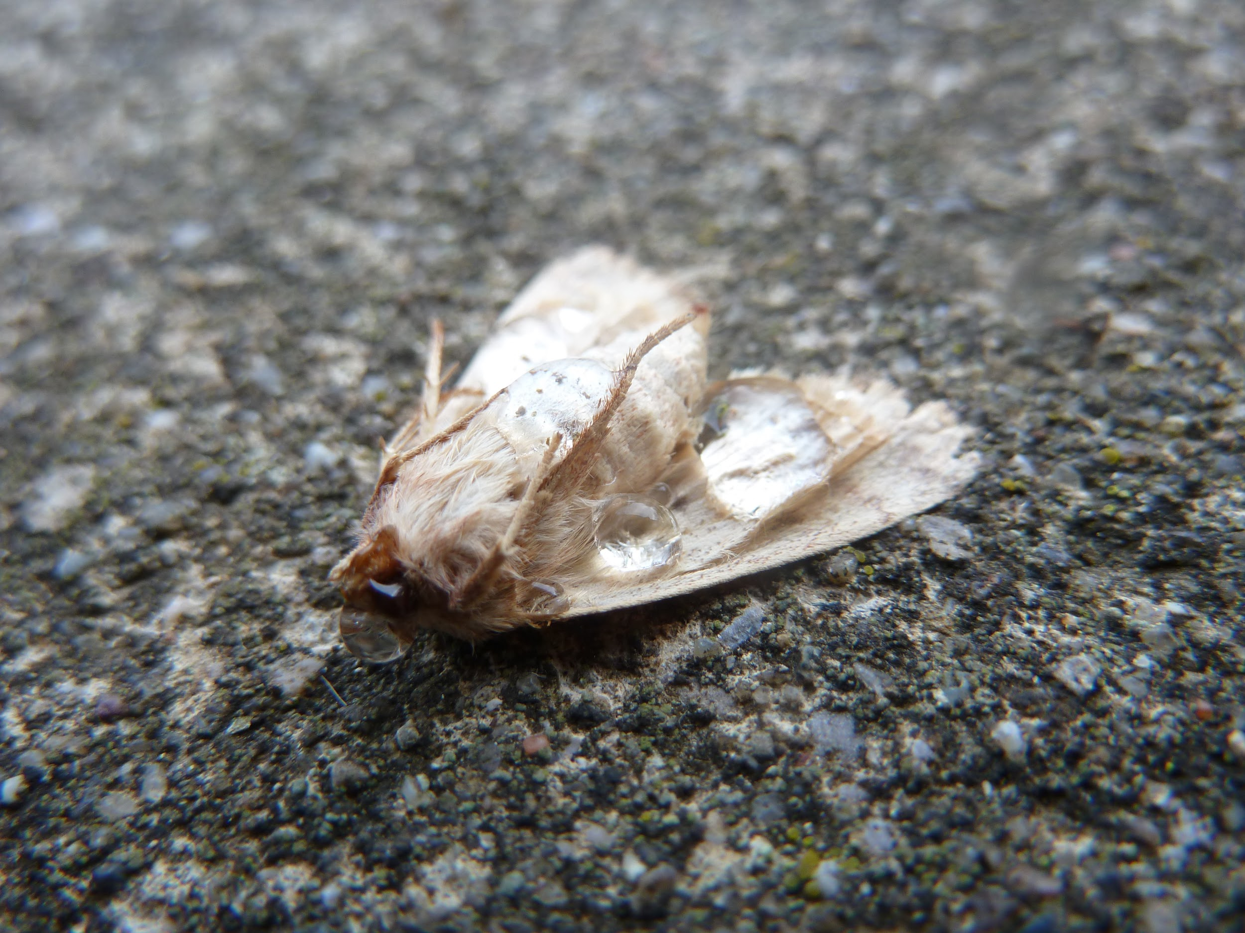
This is a picture of a dead moth on my driveway, and it died a horrible death. Even though it wasn’t stomped on, wasn’t smacked at, wasn’t physically injured in any way, its insides were destroyed by a deadly insecticide, along with dozens of ladybugs, grasshoppers, and crickets, who were perfectly harmless to humans, but are just considered as “a nuisance.” Some of these insects were killed just because of their frightening appearance or tendency to scare people, but they actually eat life-threatening insects such as mosquitoes. If we kill all these creatures off, the dangerous insect population will peak, and we’ll see the effects it will have on us in the future.

Photojournalism
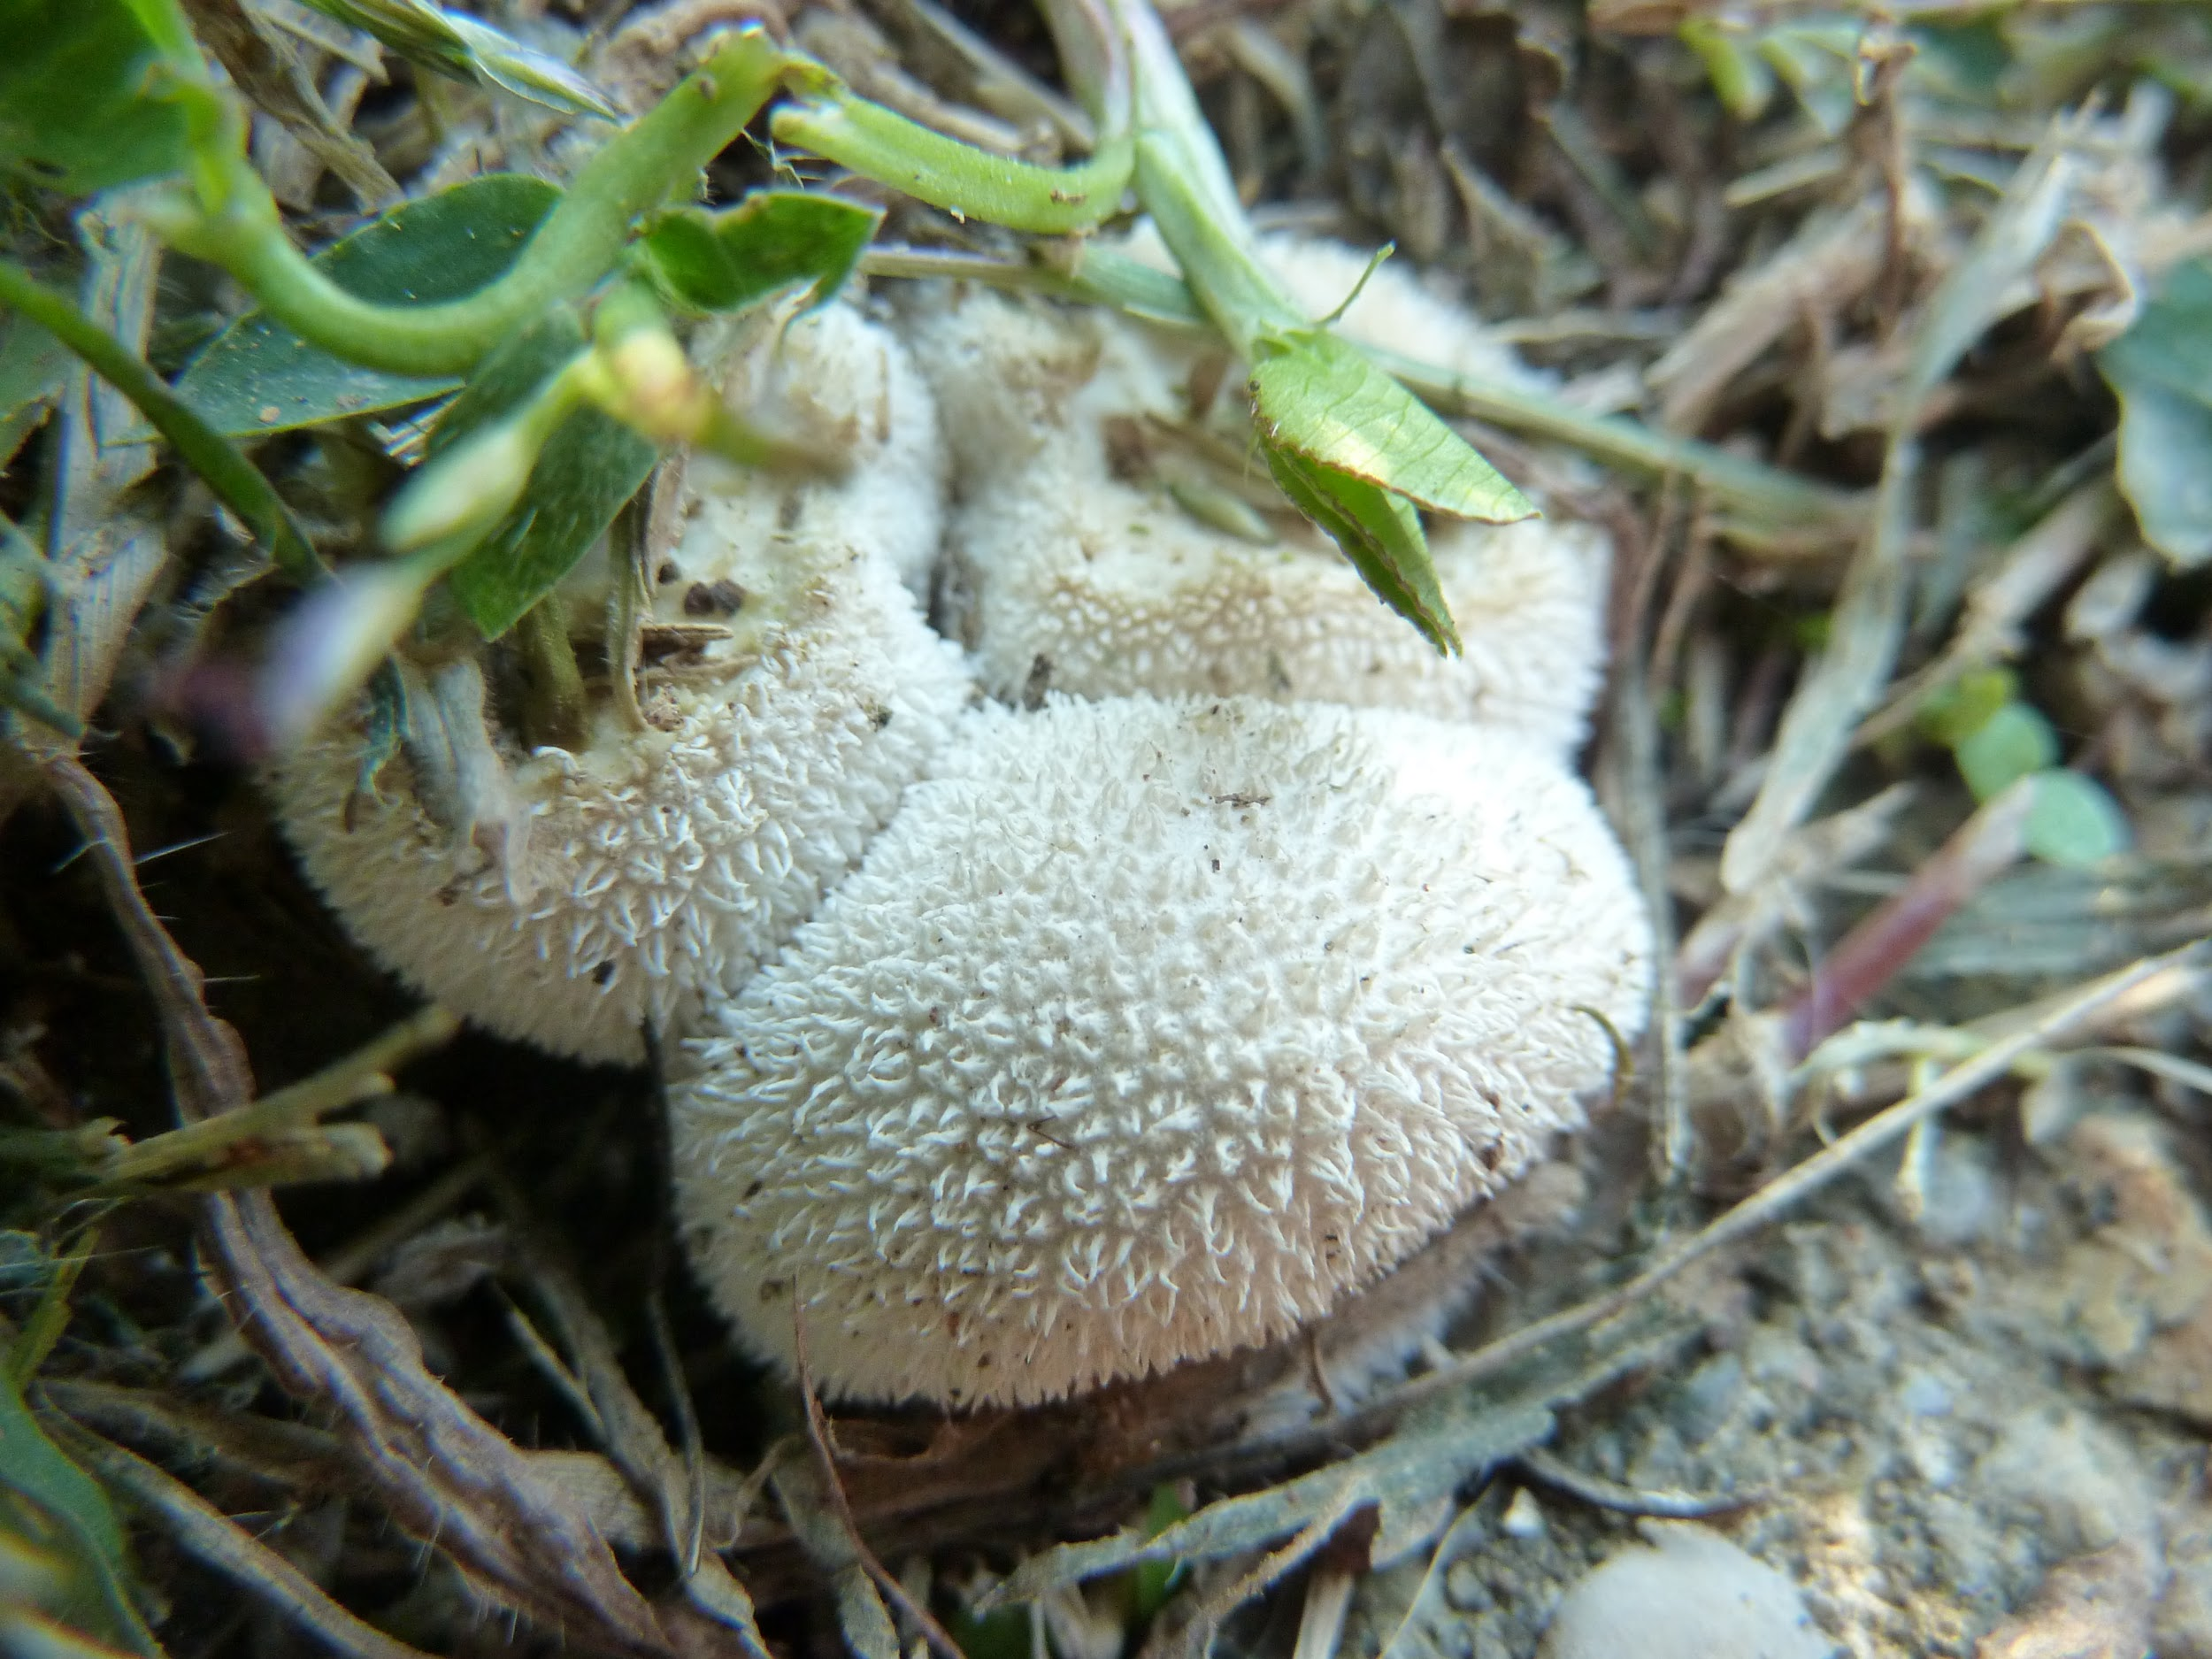
This is a type of fungi is called Lycoperdon Echinatum, and it’s commonly found in deciduous forests, glades, and pastures. The population of the Lycoperdon has since decreased due to soil acidification. People eat these mushrooms as food, but also for skin conditions and nosebleeds. Scientists have been studying these mushrooms for possible medical use. Scientists have found that the Lycoperdon provided antimicrobial and antibacterial activity against multiple diseases, such as Salmonella and E. coli. If these mushrooms go extinct, then scientists won’t be able to research more of the medical uses, and we’ll have lost a possible medicine that could have been used for diseases.

Original Photo
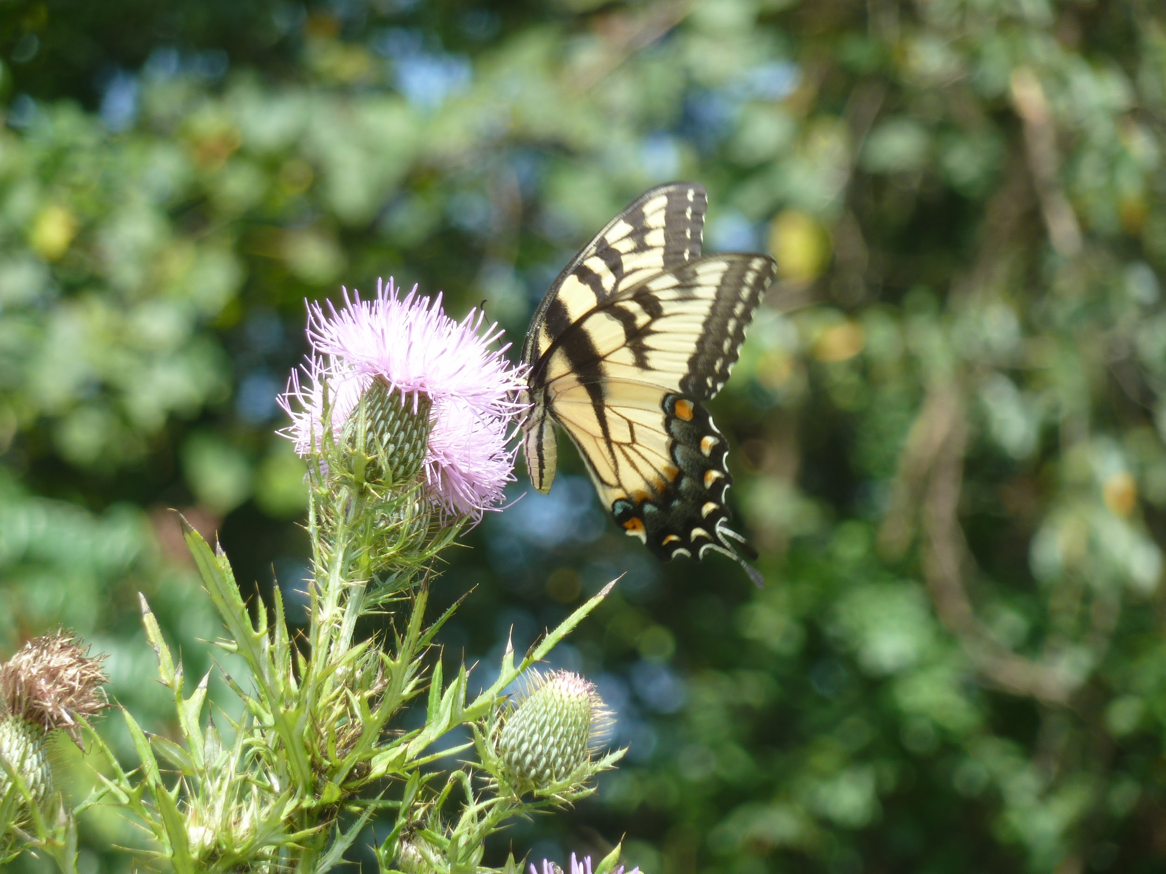
This is a Canadian Tiger Swallowtail perched on a thistle bush in my backyard. The sun was almost at its peak, and the rays hit the butterfly and the flower at a perfect angle so that the flower almost seems illuminated and adds depth perception to the butterfly. I manually focused my camera on the butterfly and not the whole scene, so that people wouldn’t be distracted by the background and would instead follow the detail of the butterfly.

