What Is Fake, Might Be Real
By Hanah Flynn

I was in my kitchen; I yawned. Shadows from outside loomed in through the window. I was tired, but I promised my German Shepherd, Oliver, that I was going to take him on a walk today, but I didn’t have the time because I had to stay late and finish a project. I sighed and headed to the foyer.
I grabbed his leash from the coat rack and yelled his name “ Oliver! Come here boy! “
The dog came running. His tongue was out, panting. He barked playfully at me before I had to put his gray collar on. I grabbed the leash and attached it to his collar. I smiled at Oliver. I put on my shoes and jacket and headed out the door. We started walking to the front of the neighborhood. It was a bit of a country neighborhood with plantation style homes, barns, and large spaces in between. Other people liked to decorate their houses suburb style, with window boxes and shrubs lining the walkway. Oliver stopped and started to sniff around a mailbox. I waited for him to do his business.
I looked into a near hedgeline. My whole neighborhood was surrounded by a forest near the hedgeline. It gives Oliver privacy to do his business on someone else’s mailbox. It was like an enchanted forest, it was beautiful and dark. It had that little urge that makes you want to explore it. But then I saw it. I could barely see it, but it was there, calmly staring at me in an eerie way. Like when somebody is staring across a room, into space without knowing it. Staring through me. It was a human shaped black figure with white almond shaped eyes. I froze.
It opened its mouth, showing a white space where the tongue and mouth should have been. I looked down at where my dog was, but he wasn’t there. I still had the leash in my hands.
“ O-Oliver?? “ I asked, looking back at the figure. A black figure the shape of a German Shepherd stared back at me. The dog growled at me quietly.
“ O-Oliver! Where are you!? C’mon boy! W-we need to go home! “ I whimpered frantically.
The dog then barked at me and started to chase me. I screamed and dropped the leash, tears falling from my face. My stomach was knotted from the fear that it was going to hurt me, or worse. Kill me. My sneakers squeaked as they ran against the grass. My heart was thumping with adrenaline. The dog was almost to me until I reached my house.
I opened the door and slammed it, locking it. I looked outside the window but nothing was there. Oliver, my sweet dog, the one that ran to me when I came home from work each day and always loved to see me. I couldn’t believe this was happening. My body felt like it was going to collapse from running. I wondered if my sweet puppy was still alive. I sighed. It was now 12:00 AM. I locked all the doors and windows and shut the blinds. I walked to my bed, tired and saddened. I put on my pajamas and hopped in bed. I looked at the ceiling. Trying to process that I had just lost my Oliver and almost got mauled by a shadow dog. 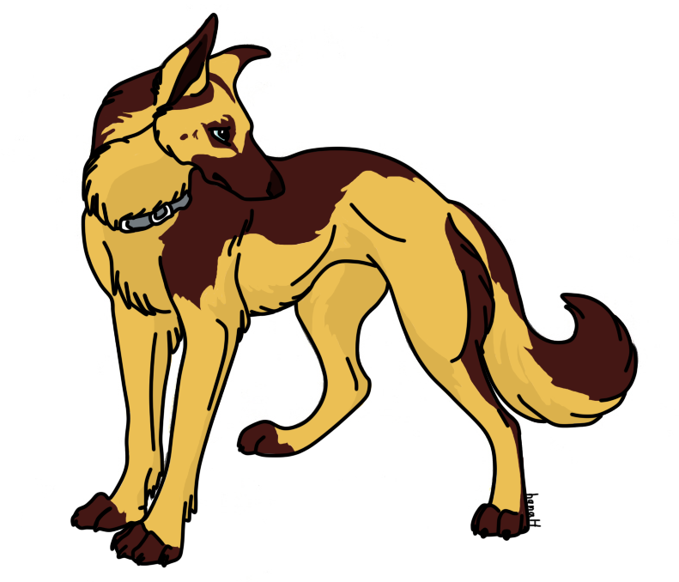
I sighed and closed my eyes after putting the covers over my legs and fell asleep. As the sun shone through the window next to my bed where I laid the next morning, I got up and yelled for Oliver. Then I remembered. I sighed and made myself some breakfast. I grabbed a bowl of cereal and ate it while watching the news. 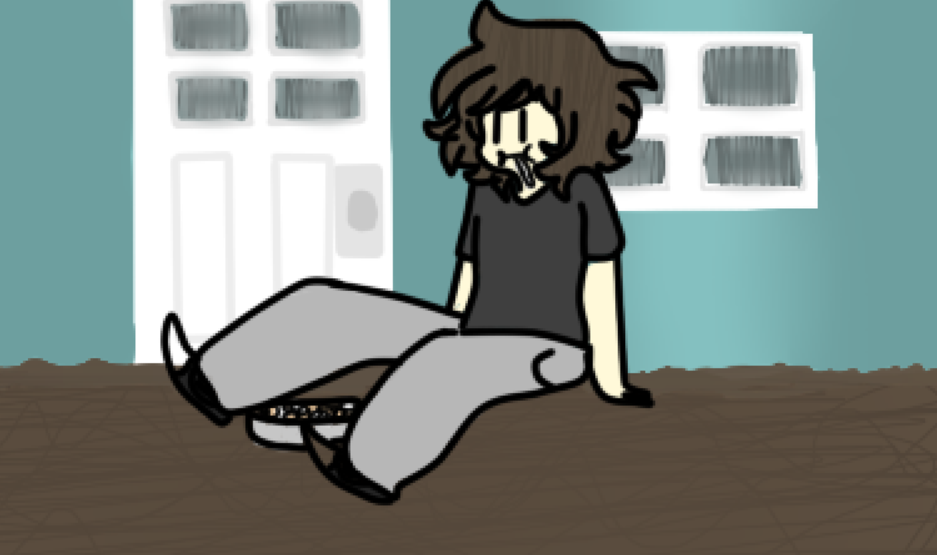
A kid went missing when her and her older sister went in the woods. The world blames the bigger sister because she was the only one there. No one could have taken the little sister. They were sure of it.
But the bigger sister says otherwise, “It wasn’t me, I swear! I loved my little sister so much. I was walking with her in the forest until a figure appeared. It looked like a human. It was black and it had white eyes. I was about to make a run for it until I remembered.. my sister.. I looked down to where my little sister was and she wasn’t there, “ She said in a trembling voice, her bottom lip shaking. “Then I looked back at the figure and there was another figure, it looked like a human too. It was black and it had white eyes as well… But it was as tall as her and it had her pigtails. My god, I miss her so much.“
The sister broke down in tears. I felt bad for her. I couldn’t imagine losing a little sister that was with me all my life. But I couldn’t help wonder, is this what happened to my dog? I needed to find out.
I put on my jacket and my shoes, walking out the door. I went to the place that my dog was taken. I walked into the forest, having my pocket knife with me, holding it close, being cautious. I walked in it for a bit until I saw a little girl. She looked a bit like the picture that they showed on the News of the the girl’s sister.
I ran to her. “ Hey! You, who are you? And why are you here? “ I asked.
She turned around and looked at me. She chuckled and replied. “ Ah, You see, I should be asking who yOU are. Then again, I know who you are. You lost Oliver, am I right? “
I started getting creeped out.
“ H...How do you know this..? “ I asked quietly. She smiled devilishly, she started to grow taller, her figure turning black with her eyes white and almond shaped.
“ You...you took my Oliver! “ I yelled. I grabbed my pocket knife and charged at her. She grinned with her wide smile and stood there, as I jumped to jab my knife in her chest, she hit me back with a her long arm, throwing me down. I hit my head against a rock that was behind me and I passed out. I soon woke up. I sat up and looked over; I saw the girl that took my dog. The dog that almost killed me earlier was next to her sitting down. I was staring at them, my face filled with fear, the girl smiled.
She examined me. “ Ah, I see your transformation went well. Hey, you have a extra as well, to help in battle I suppose, horns. “
I looked at her, confusion pouring out of me, I cocked my head.
“ What? Transformation..? “ I asked, I looked at my hand, I quickly stood up, I was taller than usual and a black creature.
“I’m….you!? “ I yelled.
The girl chuckled. “ Yep. And you have horns too! Great. You’re the best transformation yet. Well, you are the one in the legend. “ I rose my head.
“Legend…? “ I asked.
She put on a straight face. “ ‘ The one to come bring our kind to power, bring peril to the humans, make them like us monsters, to take care of us,- “ She got cut off by Oliver
“ -The one to love us, will come. And save us. ‘ “ he said.
I looked at him in shock. “ You can talk!? “
Oliver nodded. “ Yeah…. When you transform into this shadow form, you can basically do the thing that you most wanted to do when you were your last species. “
I looked down. “ I must be dreaming… “ I rubbed my head. “ Did you guys have a choice to become this? I mean, I know this seems pretty cool, but what about your loved ones? They might become like you. But, different. You turned out different, right? You left your sister and tried to hurt her. I know this seems happy and everything.. But…. “ I sighed.

The girl tilted her head. “ Well…. I never thought of it like that… “ She said.
“ We have someone that actually tells us what to do.. Like to kill people or just stalk them until the right moment to pounce, either way they end up dying unless the boss says otherwise.. “ the girl said.
Oliver and the girl looked at each other.
“ How about we go to them and have a little ‘talk’ about why they are doing this? I mean like...what about your family? What if your leader makes you kill them? What are you going to do then?
Oliver and the girl nodded, agreeing to my statement.
“Oh, this is obviously Oliver, but, my name is Grace,“ she said.
“Nice to meet you Grace, I’m Hanah. “ I said. She smiled at me and I smiled back.
“ Alright then, do you know where this is? “ I asked.
She nodded her head. “ Yeah. But, it takes a long time to get there on foot. “
“ No problem! I have a car. “ I said.
She made an ‘ oh ‘ sound. “ Then let’s go. “
She smiled, We walked back to my house and got in my car, me still getting used to my new form, I banged my head against the door frame, I winced and put my head a bit down while I got in. She lead me to a place in the forest, but, it looked like no one had been here before. It looked abandoned, it took us a while to get in the forest, deep I mean. It was pretty big. I got out of my car along with Oliver and Grace.
“ This is it… Huh? “ I asked.
She nodded. “ Yeah…. C’mon.. We don’t find him, he finds us. “
This started to creep me out., I was overwhelmed with fear, thinking of what he could do, I mean, he was their boss, if he got into that position than he would have had to do something to get there. I nodded quietly as we walked in the forest, wandering around, waiting for him to find us. We stopped as I heard footsteps. THe footsteps slowly came around to in front of us. Huge, white eyes stared at us from the thicket. Eerie breathing could be heard as the thing just stared at us. Just then, it jumped out! RAWR! “

I yelled. My little sister shrieked and fell back. “ AGH! Hanah! You’re so mean! I thought you were going to tell me a cute story! Not a horror story! “
She huffed cutely.
“Then why didn't you stop me half way through? “ I asked with a devilish grin on my face.
She puffed out her cheeks and crossed her arms.
“ Because… I liked it and it was interesting… “ She mumbled.
“ What was that? I can’t hear you.~ “ I joked.
She talked louder “ I liked it! Okay? “ She growled. I chuckled. My dog came running in the room and started to lick my little sister’s face.
“ So cute. “ I chuckled. She huffed as she played with my dog.
“ Go play with Fox. “ I smiled, pointing outside my room. She chuckled and nodded, running with my dog Fox. I walked to the window, it was still raining. I crossed my arms and opened the window. I looked into the hedgeline. And I saw him, staring right back at me, as I stared at him, two familiar faces, watching each other through the tinted window with droplets of rain on it.
